ST511 Project Report

Vijay Tadimeti

[tadimetv@oregonstate.edu](mailto:tadimetv@oregonstate.edu)

**Introduction:**

For this project I have decided to use the IMDB Top 250 Movies database. It contains columns/variables that include Rank, Rating, Title of the movie and the number of Votes. The data includes a list of 250 movies each of which has a rating out of 10.

Population: 250 films that meet the eligibility criteria

Variable of Interest: In this dataset we'll look at the IMDB User Score instead. Possible values are between 0 and 10.

Scientific question: Is the average IMDB rating equal to 8.2 for movies in the top 250 list?

Statistical translation: “Is μ = 8.2 ?”

Exploratory Plot of the data: Here, I have chosen to use a histogram to describe the data.

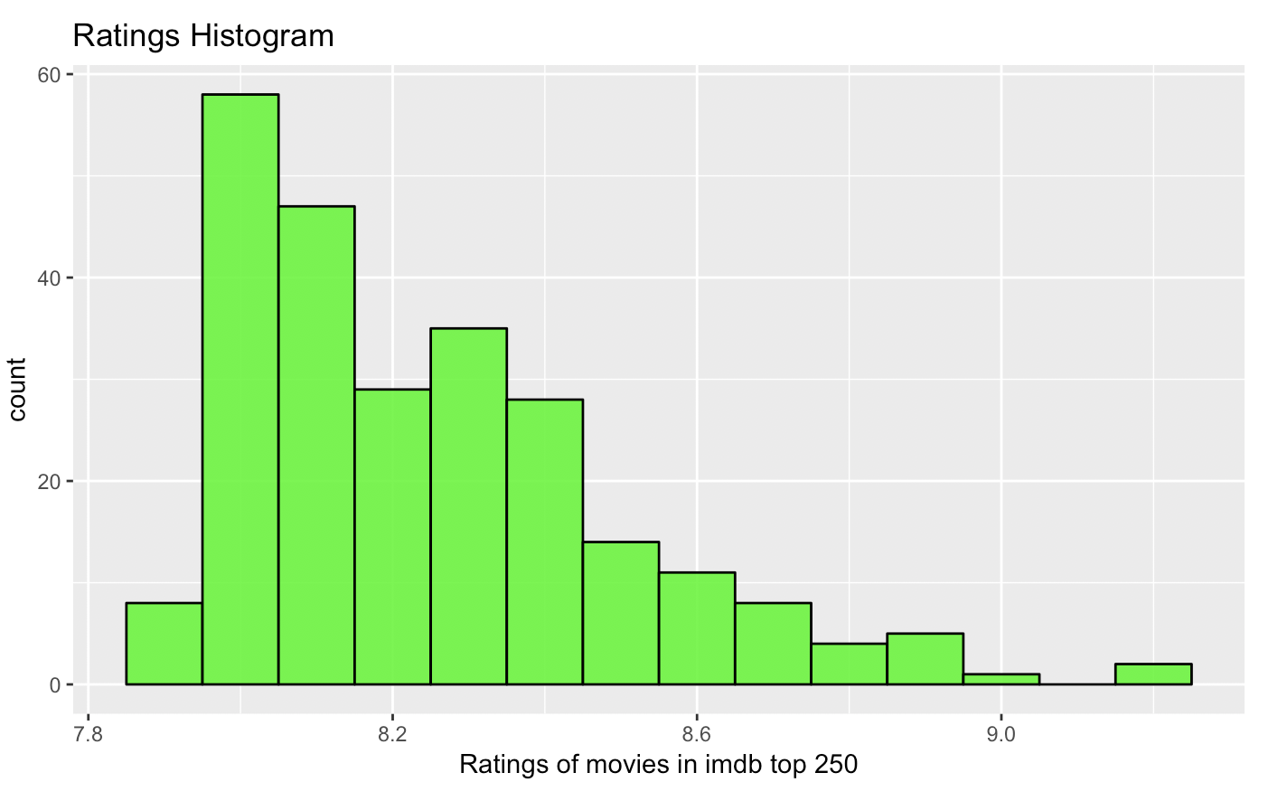

**Methods:**

I have chosen to perform a T test on this data. I am assuming that I do not know the population variance σ2. To be precise I’m using a One sample t-test. I have observed the following T statistic, and p value, both of which are mentioned below.

**Results:**

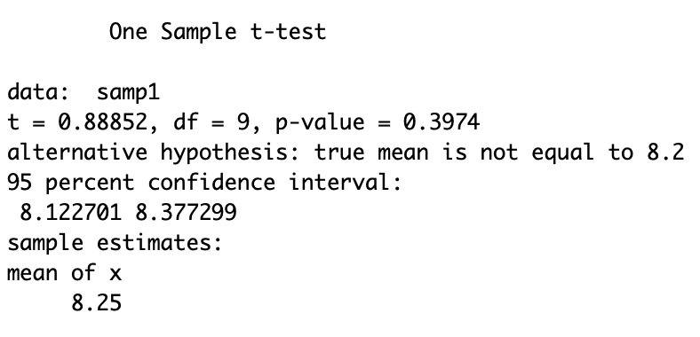

I have observed that the T test has provided me with the following values.

T statistic = 0.88852, p = 0.3974 at a confidence interval of 0.95.

**Assessment:**

1. The statistical independence of the observations within each sample.

2. The Normality of the underlying population distributions.

To assess assumption 1 you have to think carefully about how the data were obtained. Typically, data that are collected close together in time and/or space, or data that are collected together in some kind of cluster.

To assess the Normality of the underlying population distributions, you have to take a look at the shapes of the sample distributions and make a judgement call about whether you think the samples could plausibly have come from Normal populations.

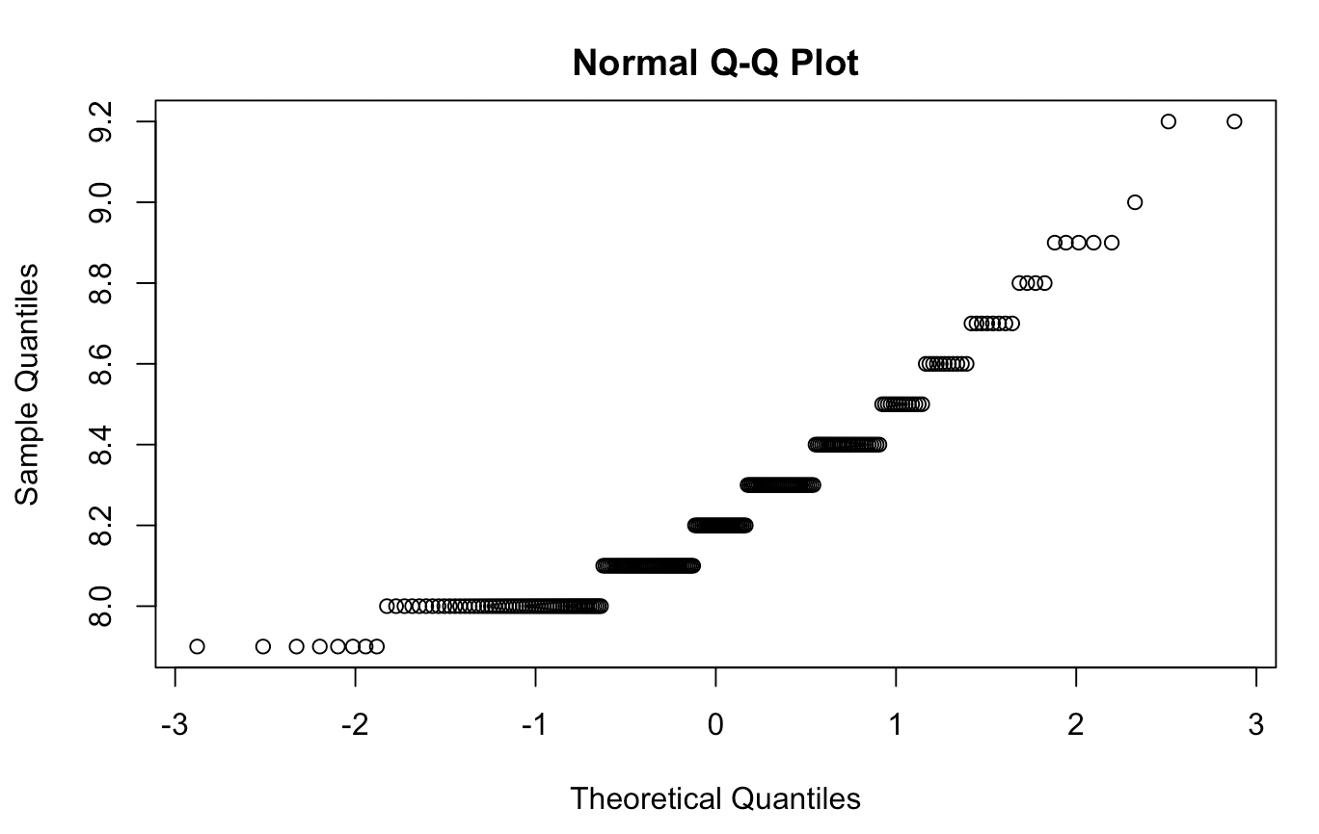

**Conclusion**:

We fail to reject the null hypothesis $Ho:\mu=8.2 at significance level alpha=0.05, since our p-value is greater than 0.05. We do not have strong evidence that the population mean IMDB Rating is greater than 8.2, so we can not rule out the null hypothesis.